From http://kaweahoaks.com/html/ants.htm
In a colony of ants you find wingless, infertile female workers predominate in defense, foraging and brood-tending. The fertilized winged female becomes the queen and may found her own nest after the mating season. In some species they may also stay in the colony or the surrounding area. Males die after mating. The queen starts laying eggs that develop into white larvae, then pupae and after that adults. In some species the queens start their new colony alone, in others they leave with workers from the old nest. Queens starting on their own do not have a lot of food to begin with which is why the first workers are normally smaller than they are in a big nest. Some queens, like Atta (Leafcutter Ants) also lay special non-fertilized eggs that are for eating. When times are hard the young queen must eat the eggs, larvae and pupae to stay alive. But as soon as the first workers appear she is out of trouble. The first adults immediately start foraging or hunting for food and brood-tending. Then the queen has only one job left to do: laying eggs. Out of the thousand of winged queens only a few normally stay alive (a lot are eaten by insects, young birds or die of hunger) to build a new colony of ants.
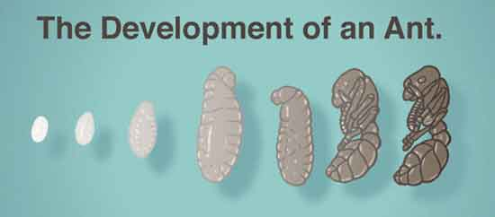
The larvae are fed from a few weeks to several months. Pupae can be naked or covered with a substance they secrete at the end of the larval state. At the end of the pupae state, the adults have reached their full size. During their growth stage, the immature ants are fed, cleaned and attended by adult workers. Commonly the pupae are incorrectly called ant eggs, but the true eggs are much smaller.
Most ants build some sort of nest under and above the ground, in trees and houses where they live and bring their food to. They are generally omnivorous, but some need special food. You may find agricultural or pastoral habits. Fungus-growing ants cut leaves and bring them home to their nest to fertilize the fungus gardens they build. This kind of fungus can only be found with the leafcutter ants. The Harvester Ants frequently visit grass fields to harvest and store the grass seeds. Specialized workers crack the seeds for the other ants to eat. Many ants eat the sweet fluid excreted by aphids. Some species keep and protect them - sometimes even in their own nests. Honeypot ants feed certain workers used as living containers with enormous quantities of honeydew. Thus their bodies become so big that they cannot move any more. The nests of the army and driver ants are built out of the clustered bodies of millions of workers hanging down from a low branch or log. In this cluster the queen and brood are enclosed. After this nesting phase, the nomadic phase starts. Then the whole colony moves with the queen and brood protected by the huge soldiers who kill everything that comes into their way. In an area where the army or driver ants passed through you will not find any living insect left. Even young birds that are unable to fly, lizards and other small animals are killed if they cannot get away. Some ants are temporary or permanent parasites in colonies of other ant species. After forays against other ants Amazon Ants bring back unconsumed brood to serve as slaves as soon as they have matured.

